Git and Github  
**Initially you have a spring boot project in your local and you want to move that to github, how to do that ?**

Here you go with simple step by step explanation with screenshots.

1. Download git first and open the exe file and run it.
2. Then open command prompt at the file location and give **git init**.
3. If there is not github installed then it will throw   
   **fatal: not a git repository (or any of the parent directories): .git**
4. If present and given git init then it will show :  
   **Initialized empty Git repository in C:/in28mins/restful-web-services/.git/**
5. Then give **git status** you will get :  
   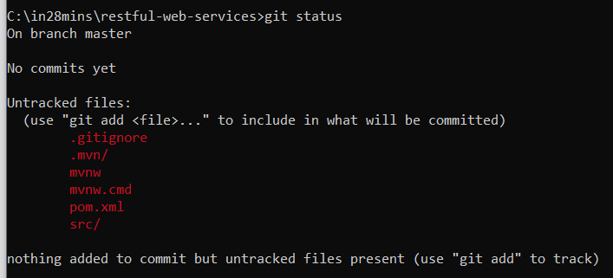
6. Then give **git add .**  
   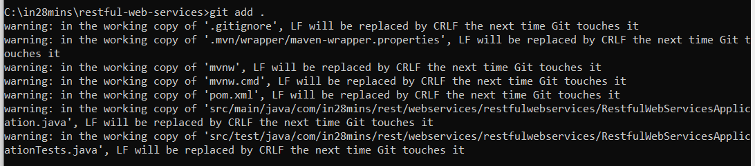
7. Again give **git status** you will get :  
   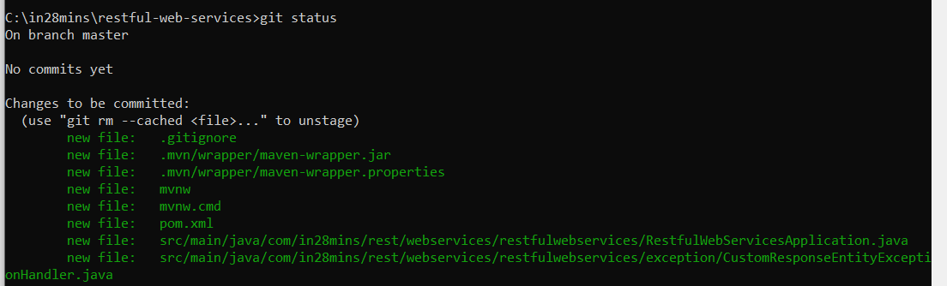
8. 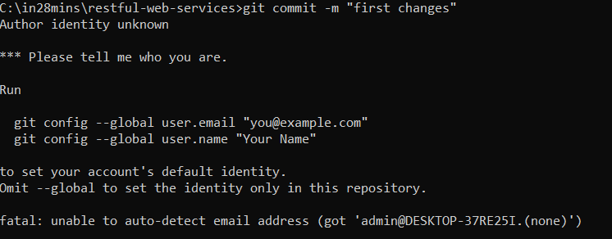
9. After enter above two git config commands correctly then give git commit again.  
   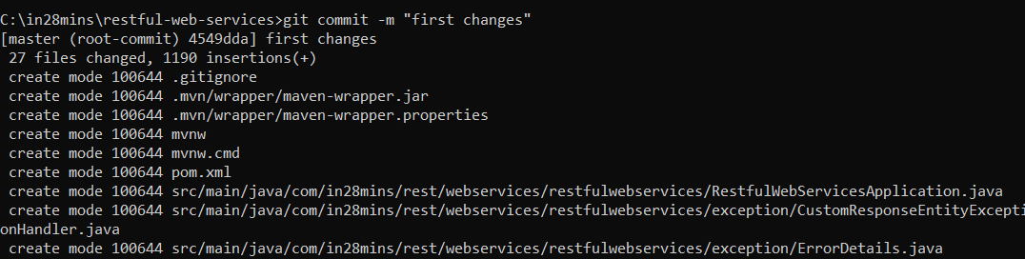
10. 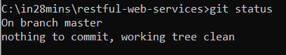
11. 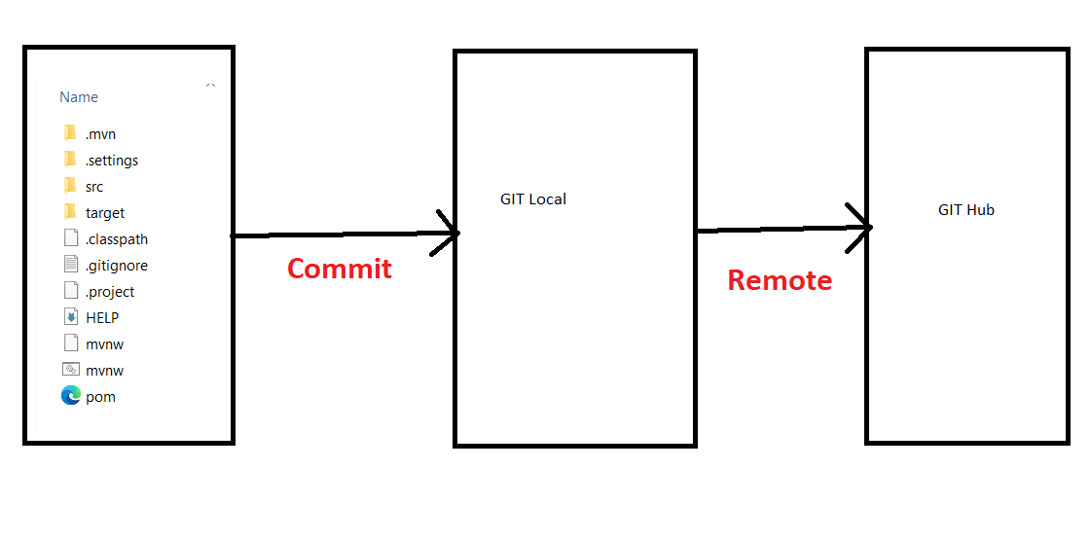
12. create a repo in github or you can use existing repo. For demo sake I have taken new repo.  
    Then from repo you will get the url and try to do like below :  
      
    Then give as below   
      
    complete authentication using username/email and password.  
    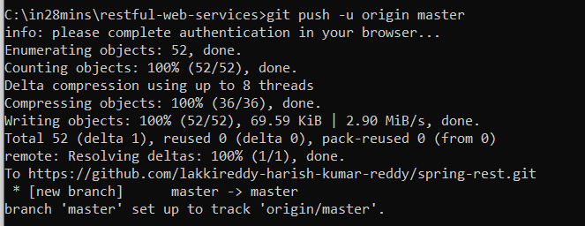
13. 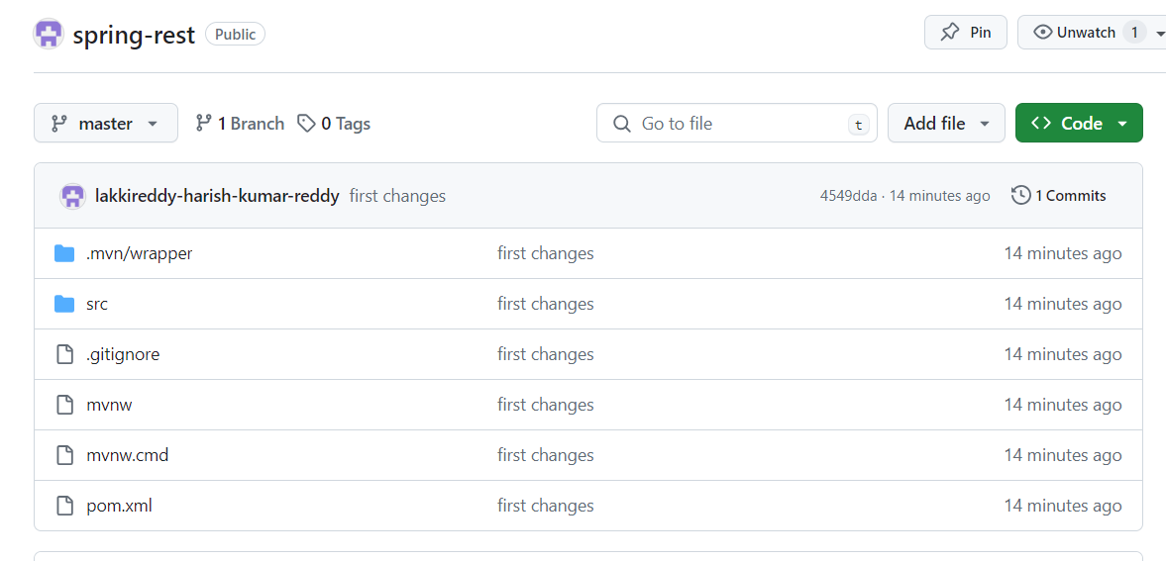
14. You can add readme file as well. After writing some content in Readme file you can pull it to your local.  
    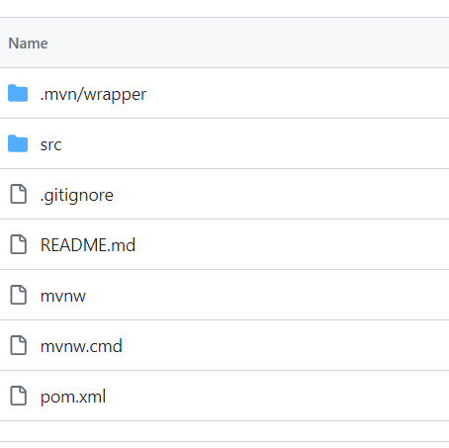  
    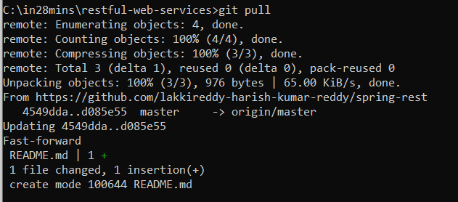
15. Extra commands which I use regularly .  
    if you want to clone a repo into your local then   
    **git clone url**  
      
    if you want to create a new branch that will not be visible in github.  
    **git checkout -b newbranchname**  
      
    **git status  
    git add –all  
    git commit -m “commit name”  
    git push**